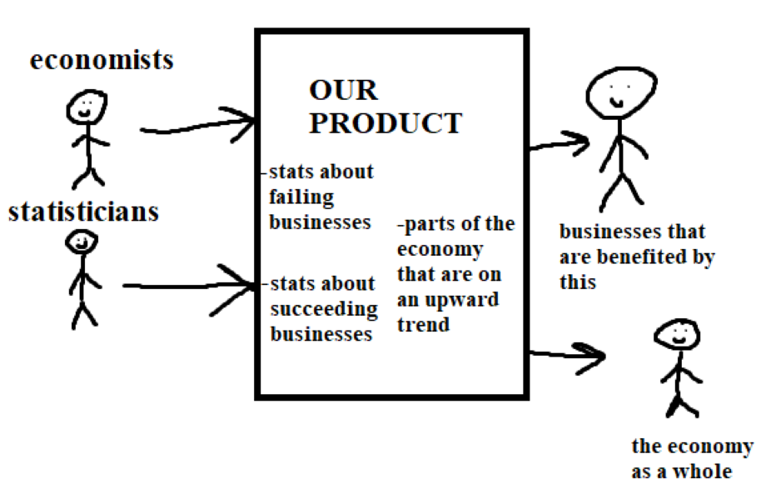

User Stories:

As a statistician, I want to be able to easily export certain pieces of data to use in my research so that I can easily obtain these pieces of data.

As an economist I want to be able to see all different types of data in one place so that I can have an overview of the US economy without looking in a ton of different places.

As the owner of a small business I want to see what other small businesses in my field are succeeded so that I can emulate some of the things they are doing to help them succeed.

Feature list:

Ability to export data, either from entire website or certain pages.

Ability to see more generalized data, probably on the homepage or something similar.

Ability to see more specific data, from certain fields or industries.